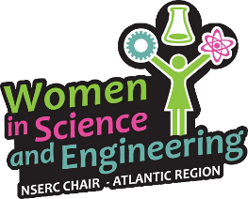
WISEatlantic Partnerships Program-
Full Application
Organization or Individual’s name: ____________________________________________________
Project Title: ___________________________________________________________
Project Dates: ___________________________________________________________
Funding Requested: ___________________________________________________________
Organization/Individual’s Contact Information:
Mailing Address: ___________________________________________________________
Phone Number: ___________________________________________________________
Website (if applicable): ___________________________________________________________
Affiliation:
- Post-Secondary Institution (name): _________________________________________________
- Charitable / Non-Profit Organization (name and registration number): ____________________
Primary contact:
Name: __________________________________________________
Position in Organization: __________________________________________
Email: ________________________________________________________
Phase 3: Full Application – Due November 10, 2017
Attach a free-form, detailed application of no more than three pages (plus appendices) and this cover sheet. The free-form application must include:
- A summary of your organization - The need for your project
- A summary of your project - The impact of your project
Appendix I: A one-page budget table specific to this project clearly outlining expenses and any revenue sources. The budget must be balanced and show where additional funds will be obtained if applicable.

Appendix II: A one-page budget justification for each item listed in the budget. Please note that all expenses must comply with NSERC’s list of eligible grant expenses, as well as Mount Saint Vincent University’s policy for travel (e.g. per diem travel rates). For a complete list of NSERC eligible expenses click here. For details on the Mount’s policy please contact us at WISEatlantic@msvu.ca

